Statement of Ethics

Adopted by the
Westmoreland Conservancy
Board of Governors
2/23/2011

Reviewed 11/16/2022

We dedicate ourselves to preserving the unique character of Western Pennsylvania’s natural landscapes and sites for all generations. Goals and actions meet our vision for conservation:
To preserve natural, rural, and historic landscapes for Nature’s benefit and the enrichment of future generations.

As a private, non‐profit organization, we have an obligation to provide a public benefit. Therefore, we strive to avoid any conflict of interest or provide benefit to any member of our Board of Governors or other individuals that violates the public trust. Our actions should enhance the reputation and credibility of the land trust community.

We pledge to conduct our land protection and organizational activities under the highest
professional standards in accordance with the Land Trust Alliance’s Standards and Practices.
https://landtrustalliance.org/resources/learn/topics/land-trust-standards-and-practices/

We acknowledge the trust placed upon us by our donors and the public by being fiscally
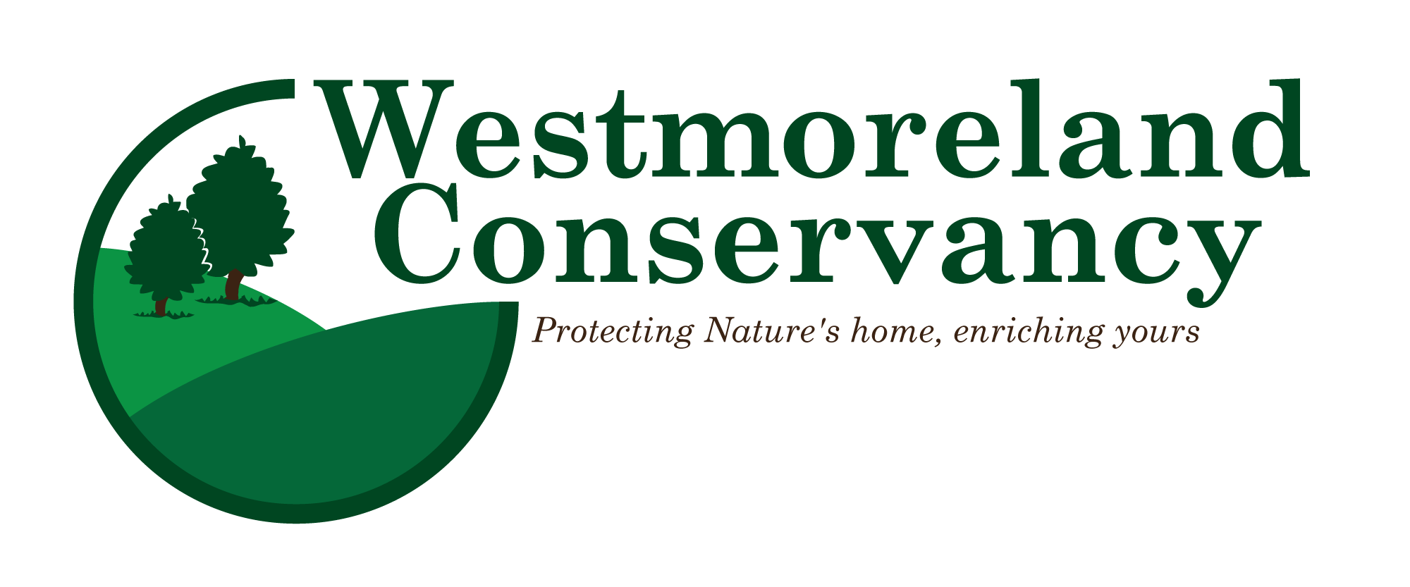
responsible, by always considering our long‐term responsibility to the lands we protect and by building a sustainable, capable land trust organization. In addition, we pledge to foster open and productive relationships with landowners, other land trusts and the public.

